2024 Kumeu Village Chardonnay

VINEYARD REGION
Kumeu & Hawkes Bay
Vineyard area covering 14 hectares.
Vines planted between 1989 - 2016

VINIFICATION
Indigenous yeast fermentation
100% malo-lactic fermentation
30% Barrel fermentation
(5 year old + French oak barriques)
70% Tank fermentation
13%vol
WINEMAKER:
Michael Brajkovich, MW

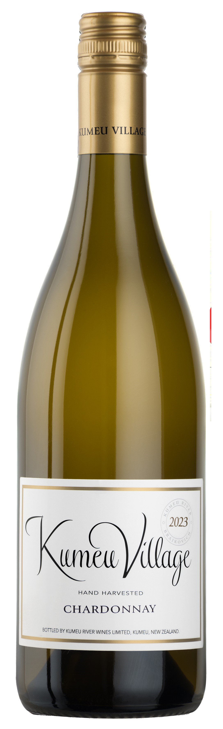

Produced from grapes grown in Kumeu and Hawkes Bay (50% of each) this wine was fermented 30% in old French oak barrels, and 70% in stainless steel tanks. The barrel fermentation provides some richness but very little oak influence. Combined with the tank fermentation this allows the vibrant fruit to show through beautifully with lively lime and lemon aromas and a flinty, mineral palate with hints of fig and white peach.

The 2024 Vintage gave us outstanding quality, both in Kumeu and Hawkes Bay, with beautiful fruit aroma, flavour and concentration. Our own Rays Road vineyard in Hawkes Bay made up 8% of the final blend, which gives the wine a distinctive limestone edginess. The moderate alcohol level of 13.0% gives freshness with a lovely flinty texture. The citrus elements of Chardonnay shine through with a refreshingly crisp acid finish. This wine is delightful as an aperitif, and even better to drink with seafood.

